How to Create a
Conference Poster

Revision date: August 13, 2018
Contact: research@csmls.org

Table of Contents
What is a Conference Poster? 3
Components of a Poster 4
Text Size 4
Text Type 4
Colour Contrast 5
Picture Background 6
Design Program 7
Poster Size 8
Cost to Print a Poster 8
Before You Print 9
Poster Content 10
Poster Anatomy Guidelines 10
Table, Figure or Text? 11
Poster Presentation 13
Professional Appearance 14

How to Create a Conference Poster

What is a Conference Poster?

Basically, it is a summary of the research or project, which you led or helped support, that is displayed on a big piece of paper. However, it has more importance than this simple definition. When you create a research poster, you are making a concise and interesting way to advertise your hard work and findings that will help further laboratory processes, science, policy, patients and/or other stakeholders in the future.
Displaying information using a research poster is a great way for students and young professionals to attend conferences with a purpose and a conversation starter, get exposure through networking and expand their CV for employment purposes. For established professionals, it can highlight major projects at work, such as a new automation process in the lab or validation of a new point-of-care device, helping to support career expansion and workplace recognition. Lastly, for researchers, the poster signifies a way to present research that may not be big enough for a presentation but is still important enough to share with peers. It simply provides an avenue for a presentation that may be most appropriate (e.g., describes a project mid-process, provides preliminary exciting data and/or fills in a gap of information).
Conference posters generally display qualitative and quantitative research.

However, you can also use conference posters to display process improvements, impacts of policy changes and other quality assurance projects conducted in your lab. You just have to collect some data, which can occur after the project (albeit, it is best to plan ahead!)
Once you have finished the conference, hang your poster in your department and spend time discussing your work with other health professionals to tell them that medical laboratory professionals are active in and conducting research!
The poster itself is usually a mix of pictures, graphs and text, which are displayed in the same type of layout as an abstract. The amount of each concept you use depends on the type of image you are selling and the type of research you have conducted. Think of the poster as a marketing tool, with a strong focus on design. As we know, the presentation of commercial products brings consumers to the table. Generally, although not always the case, this is how your poster should be structured:
Qualitative | Quantitative
More quotes | Minimal quotes
More pictures | Fewer pictures
More colour to display project mood/tone | Fewer colours
Fewer graphs and tables | More graphs and tables
More thematic analysis using text | More concise mathematical text
More fluid layout design | More structured layout design

Components of a Poster

Text Size
How do you know what is going to be legible if you have never made a poster before? This is a common question! Well, you can ask someone, but when it’s midnight and you have to get the poster complete ASAP because there is no time to do it in a busy lab during the day, here are some guidelines you can follow:
Major Poster Sections: | Legibility of Body Text:
Title: 85pt  Authors: 56pt  Sub-headings: 36pt  Body text: 24pt (minimum)  Captions: 18pt (minimum) | Good options  Legible at six feet, use 30 pt.  Legible at 10 feet, use 48 pt.  *useful for a lot of content, few graphs/pictures  Not as good options  Legible at 12 feet, use 60 pt.  Legible at 14 feet, use 72 pt.  *useful for little text, many graphs/pictures

Depending on what distance legibility you are striving for and how much content you have, you can use the guidelines to figure out your best path.
At CSMLS, we generally have a lot of policy, project, qualitative and quantitative content to put on a poster to provide members with details of our projects. Thus, we use the minimal information described in the Major Poster Sections as noted above.

Text Type
When choosing a font and thinking about marketing your content, you do not want to choose a fancy font that is hard to read. This might sound easy to do, but there are many posters out there with text that can  your vision after five minutes. Remember this: don’t pick a text that is normally bolded, condensed, has unnecessary curves or wings, looks like it was written in your handwriting or is small even when you pick a larger font size! You want to have straight and simple text, with no shadow or unnecessary flare. If you want to be creative, use that energy in the colours and poster design instead. Calibri (the font you are reading now) is my favorite as it is slightly smaller but crisp and clean to read.
One last tip, don’t pick more than two text types. If you want to have a specific text for your title, authors and headings but a different text for your main body, this is acceptable. However, make sure that the texts are not drastically different in size or shape.

Good Fonts | Bad Fonts
Ariel  Calibri  Helvetica  Mangal  Tahoma  Verdana | Bradley Hand ITC  Freestyle Script  Impact  Segoe Print  Rockwell Condensed  Gagbriola  Times New Roman

Colour Contrast
What might look good on the screen, may not print the same on paper. The safest way to navigate this is to ensure that you minimize your colour to two to three selections. If you are completely unsure, go with this: white background, with text box outlines in a dark blue and black text. If you are not using a background design from a picture, this is the best method to use and will help your poster look professional. However, you can spice it up a little!
Not sure what colours to use? Try using the colours of your organization logo or look around the lab for inspiration. The colours you choose should not be the colours you find in a small box of kid’s crayons that you get from restaurants – primary blue, red or yellow.

Instead, you will want softer and lighter versions of these colours and combinations:

It’s not that you can’t use dark colours. You simply want to be selective about how and when you use them:
This is better…

…than a combination like this:

The muted colours won’t take away from your information whereas there is a greater chance that the brighter colours will. Unless you understand colour theory or are artistic in general, go the safer route as it has the potential to look more professional.
If you want to use primary colours, here is a good example of a high-contrast poster:
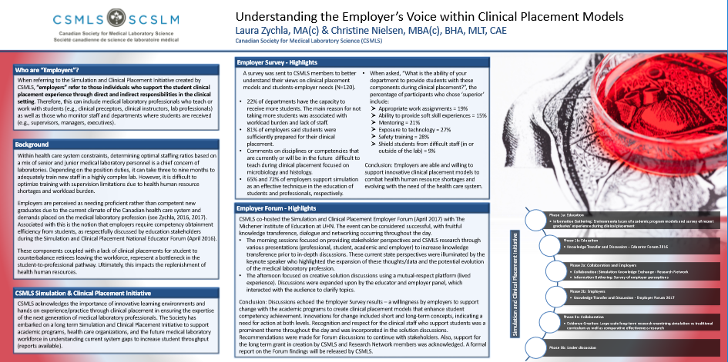
You may work in a lab, but you don’t want your poster to look like you spilled blood all over it! Bad version:
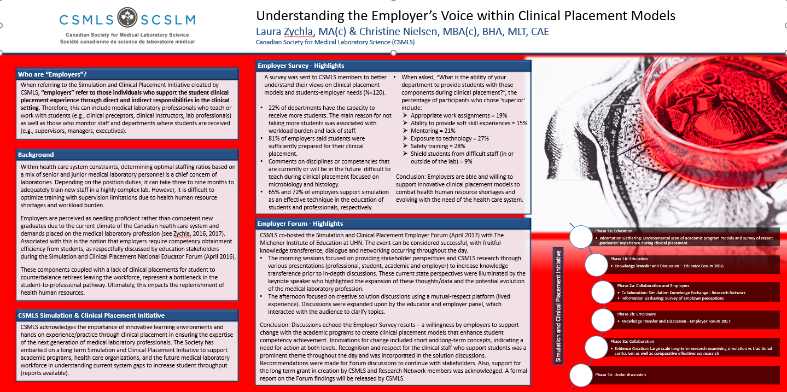

Picture Background
Using a picture to enhance your background can be an added benefit to professionalizing your poster. There are many free stock photographs of real life and abstract art on the Internet. Plug in “free stock photography” into your search engine and have a look around. Paid and free examples include iStock, Unsplash, Pixabay and Burst. Don’t get bogged down in finding a picture as the Internet can be a big time waster. When you find the right picture, you will want to make sure that it is in high resolution.
Select pictures that fit the mood, style and tone of your project; for example, in the CSMLS Mental Health Initiative, we focused on mental health issues in the workplace, which encompassed emotions such as anger, frustration, sadness and burnout in contrast to the upbeat, happy and energetic feelings one wants in a healthy work environment. In the poster shown below, you can see how the background graphic displays these two types of opposing emotional moments based on colour.
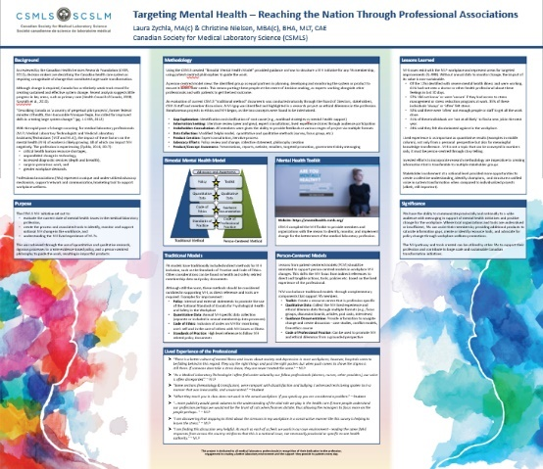

If we used only moody blues, the poster would have looked completely different and would not have been as visually interesting to attract readers at the conference. See the difference:
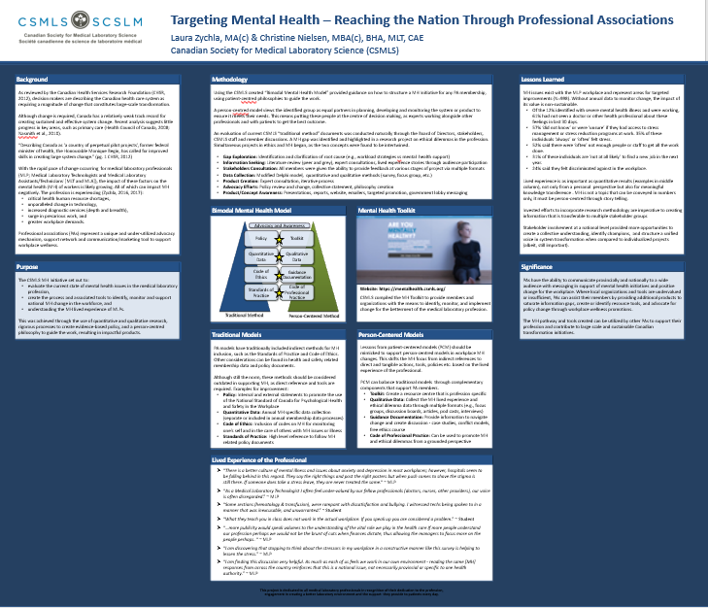
Also note, when using a flat background colour, you take the visual depth away from the poster and content. Keep in mind, the visual presentation isn’t everything. In fact, your content is the most important item, but if no one is attracted to your poster, you are less likely to have people read the content. It can be a superficial world!

Design Program
There are a variety of design programs you can use; however, many researchers use Microsoft PowerPoint (PP) to create their conference poster. Unless you are well versed in a design program beyond this one or have time to spare, PP is your best choice.
- Guide to Creating Academic Posters Using Microsoft PowerPoint 2010
- Here's How... Poster Creation in PowerPoint 2013
Alternatives:
- Purchase – Adobe Illustrator, Photoshop and InDesign
- Open Source – OpenOffice, Inkscape and Gimp.
There are many design templates on the Internet that you can use; however, the design can limit you if you create the content to fit the design. Sometimes, it is easier to create the content first and then cut it down to fit a modified design template. Nonetheless, if your brain works in the opposite direction, you might just need a design first. Pick the direction that feels right to you.
- Genigraphics
- MakeSigns
- PosterPresentations
- PosterSession
Tip: Print out a draft of your conference poster (8.5 x 11; shrink to fit) to see if there are any alignment, colour, font or image quality issues. It may also be easier to sport tapas (spot typos).

Poster Size
Your conference will let you know what is the maximum height and length your poster should be. Warning – these are general sizes usually and may not represent what the poster board size will be at the conference. Thus, it is best not to use the maximum size unless you have to because of content. Instead, you should allow for a three to four inches smaller conference poster than the board it will be attached to. A safe standard is to create a poster that is three feet high by four feet wide.
In PP, the program has limitations on what size a poster can be. To get around this, check out this video:
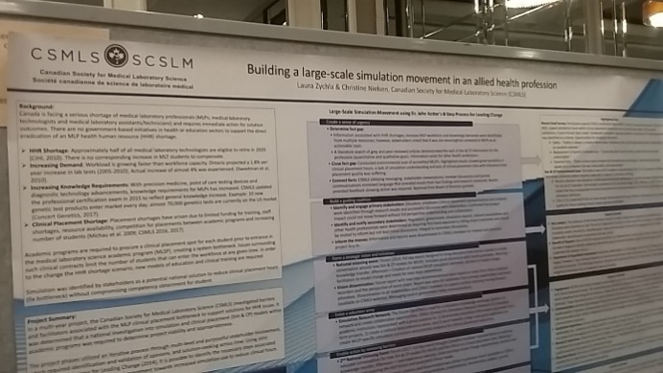
Poster Sizes – How to Properly Size Your Research Poster Design in PowerPoint
At CSMLS, we go big because we work hard for our members! This poster was made using PP. Using the ratio system, we made a poster that filled most of the board because we had a lot of content on the profession’s simulation movement created by medical laboratory stakeholders like you!

Cost to Print a Poster
The cost to print a conference poster can be different depending on your region. It is best to contact your local printers to get a better understanding of cost in addition to printing turn-around times. If you work in the hospital system, they may have their own printing system or a company that other researchers use regularly. You will want to hunt down this information from your colleagues before you venture out on your own.
Tip: Sometimes, printers give student discounts so don’t be afraid to ask! Also, your department may have a small budget set aside for knowledge transference projects or office supplies that could be used to support your poster costs. You may even have a grant fund from your organization that can help.
Depending on the size, the average poster can cost around $100 CAD plus tax. If you are creating a big poster (slightly under eight feet by four feet), the price will be closer to $175 plus tax. Printing options usually include a matte or glossy finish, with matte being the preference. The gloss will show all the fingers that touch your poster under the bright lights of a conference room. If you are offered a higher quality of paper, this is not necessary unless you plan to use your poster for several different events or places.

Before You Print
Here is a step that you CANNOT skip over! Before you print, you have to:
- Have someone else who has not reviewed the poster to check for spelling and grammar mistakes. A new set of eyes is more likely to catch errors, even when several people have already reviewed it. It’s a fact of life!
  - You can also use grammar check programs like WhiteSmoke and Grammarly for extra support. Microsoft Word and PP spell checkers are not enough.
  - You should check that your citation style follows a formalized approach, such as APA.
- Double check your poster size and that your images are in high resolution (not pixelated).
- Don’t leave the printing process to the last minute as some printers can’t handle a short turn-around time. If you live in an urban area, it is generally possible to find a ‘submit and print’ on the same day but don’t rely on this. You should expect at least a three-day wait for submission-to-print pick up.
- Play Bad Poster Bingo – If you have any of these items, evaluate your poster for potential change requirements.
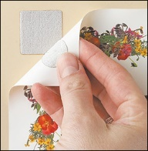
Don’t forget that you will need a way to attach your conference poster to a board. Some conferences will provide a sticky contraption of some kind or push pins to keep your poster up. However, be prepared and bring a solution with you in case the event personnel are busy or you are not provided with stickers. You do not want to use clear or masking tape as this will degrade the professional look of your poster.

Poster Content

Poster Anatomy Guidelines
This is a good place to start your guidance – read through the poster below to see the perspective of a potential reader.
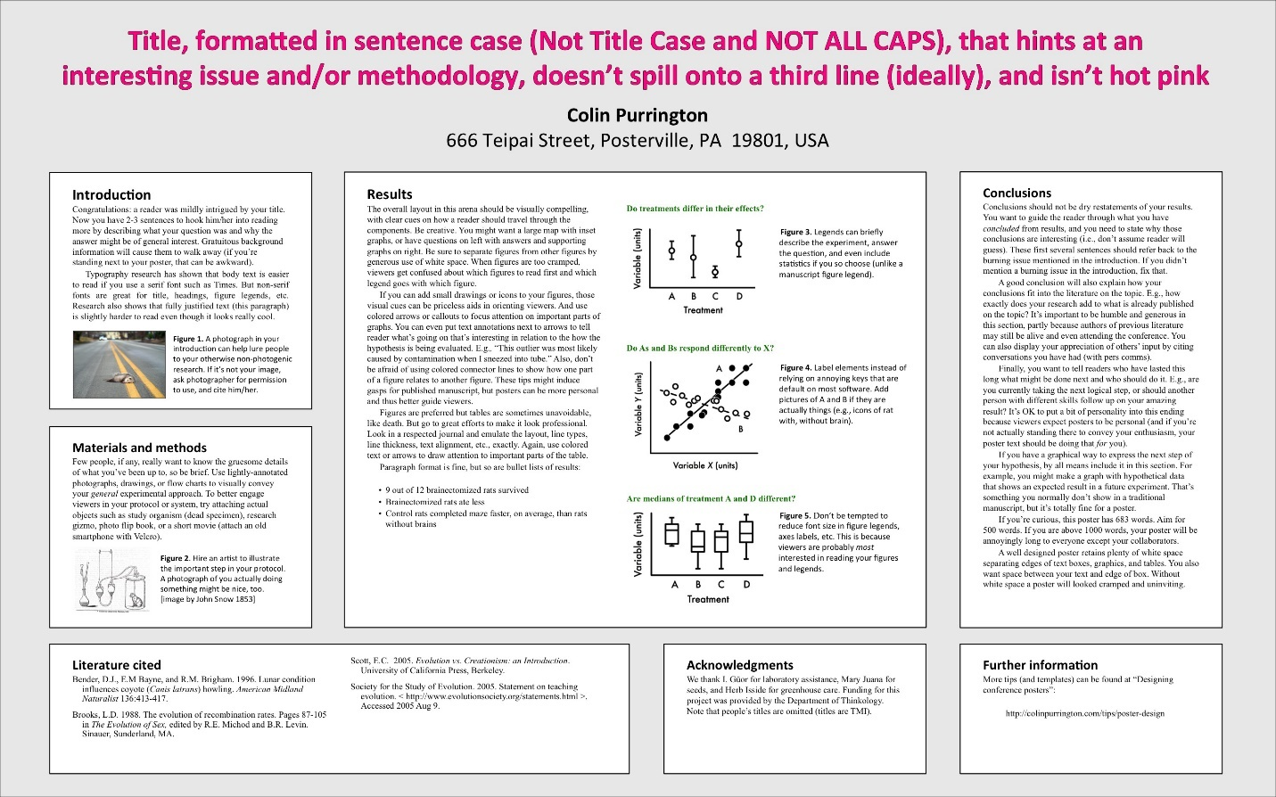
Credit: https://colinpurrington.com/wp-content/uploads/2011/09/scientific-poster-advice-purrington.jpg

Tip: The reader should be able to understand your project within three minutes of glancing at your text and should be able to read the entire poster in five to seven minutes.

A structures poster should have all or most of the following headings:
Component | Guidelines
Title | Two lines or less, preferably one  Scientific research generally has longer titles than non-scientific ones
Authors | Names (may include middle initials, author preference dependent)  Credentials (achieved or in progress, follow citation style)  Affiliations (promote your lab and organization)
Introduction or Background | Two hundred words or less  Define the issue/purpose  Highlight important research findings  Provide a rationale (justify your work’s purpose)  Provide a concise hypothesis or defined project goal(s)
Materials and Methods | Approximately 200 words  Use figures and tables to illustrate experimental design, such as flowcharts and timelines  Describe participants (pertinent inclusion and exclusion criteria)  Describe statistical plan and surveys/equipment used
Results | Approximately 200 words  Provide qualitative and quantitative results for research projects  Provide process results for quality assurance projects  Present analyses that specifically address the hypothesis  Display charts or images as appropriate (three is a good maximum)  Increase word count if there are no graphs or pictures
Discussion | Approximately 300 words  Define the outcome of your hypothesis  Discuss if/why results were conclusive  Point out relevance of findings to other published work  Discuss limitations of the work (if not in separate section)  Highlight future directions of the research (if not in separate section)
Conclusion | Approximately three to four sentences  Concise summary  Remind readers of relevance
References | Include if space allows  Follow a formal citation style
Acknowledgements | Limited space – one sentence  List funders, organizational support and non-authors who have helped, such as lab personnel and research assistants.  May not be required but important to those that supported you

You can also include Limitations and Next Step sections if appropriate for your work, but these are not necessary. You do not need to include an abstract on your poster. In your submission process, you probably created an abstract for the judges to determine if you would be accepted. This can be expanded and used as a one-page handout for attendees who are interested in your work.

Table, Figure or Text?
It is important to state that research has shown that tables, graphs and figures are critical in the enhancement of quality manuscripts for publication. These same points can be used in the conference poster arena. Determining whether to use tables, figures or text is not always easy as visual preference between authors can be at opposite ends of a spectrum. Remember that as important as your project is, the viewer only has a limited time to read your information.
Don’t forget, as many do, to include a brief caption for your figures and explicitly refer to the figure in the text. Charts and graphs always require a title and axis labels.
Consider these guidelines, based on research, to help focus your efforts:
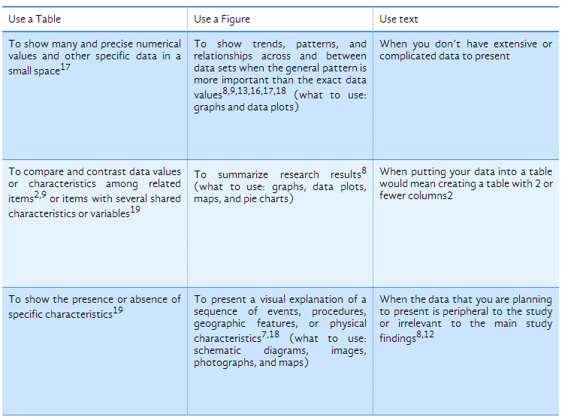
Credit: https://www.editage.com/insights/tips-on-effective-use-of-tables-and-figures-in-research-papers
It is not only what you choose but how you display what you have chosen that can make a difference. A visually effective poster will draw in conference attendees to read your poster and help them digest the content in an easy format. Let’s have a pop quiz…
Are these good or bad figures and tables to use on a conference poster?
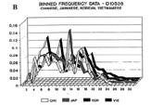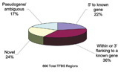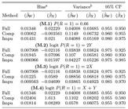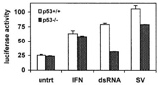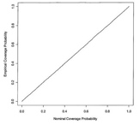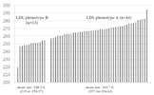
Find out the answer and reason here (click on discussion per graph)

Here is a reference to help direct your figure and table conversations:
- Effective Use of Tables and Figures in Abstracts, Presentations, and Papers

Poster Presentation
A poster presentation is an excellent way to showcase you in addition to your work and findings. It is an avenue to talk with future funders, employers and potential collaborators. You can also create a one-page handout (abstract layout) to give interested conference attendees. Don’t forget to put your name and contact information in the handout. A simple mistake but it has happened to others!

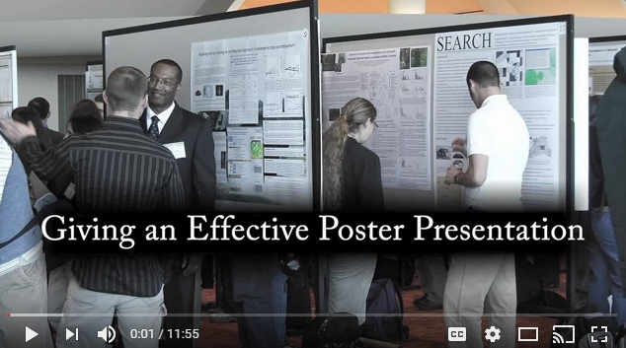

Additional resources include:
- Ten Simple Rules for a Good Poster Presentation
- Tips for presenting your scientific poster at a conference
Here is a checklist of items that you should review prior to your presentation:
- Stand up straight, smile and show your excitement for being there.
- Speak to your audience, not to your poster – face them and make eye contact. You can and should refer to your poster, pointing out key information that supports what you are saying, but make your audience your focus.
- Be cognizant of volume and background noise. Speak loudly enough for your poster viewers to hear you, but not so loudly that you disturb those next to you.
- Speak clearly and at a conversational pace.
- Practice with others before the event so that you’re prepared and comfortable.
What to Avoid:
- Try not to use filler words, such as “um,” “like,” and “you know,” as these are distracting and make you sound less confident in the information you’re presenting.
- Do not chew gum.
- Avoid overdramatic gestures or hand waving as this may scare some people off.
- Avoid perfumes or colognes; those with fragrance sensitivities and allergies will appreciate it.
- Do not read from notes.
- Have business cards available (even students should carry some).
- Have copies of a one-page summary of your work (more detailed than submitted abstract and include contact information).

Professional Appearance
Personal attire while presenting your poster should be similar to the clothing you would be wearing at an interview for a new job. It should be professional. It will be equivalent to (if a formal conference) or a notch above (if an informal conference) what conference attendees are wearing. It is highly unlikely that it will be acceptable that you dress in casual attire so it’s best to avoid this at all cost.
What to Wear:
Dress slacks or khaki pants (not cargo pants), button-up shirt, blouse, cardigan, sweater, suit jacket, blazer, sport coat, dress shoes, knee-length skirts and dresses and heels or dress flats.
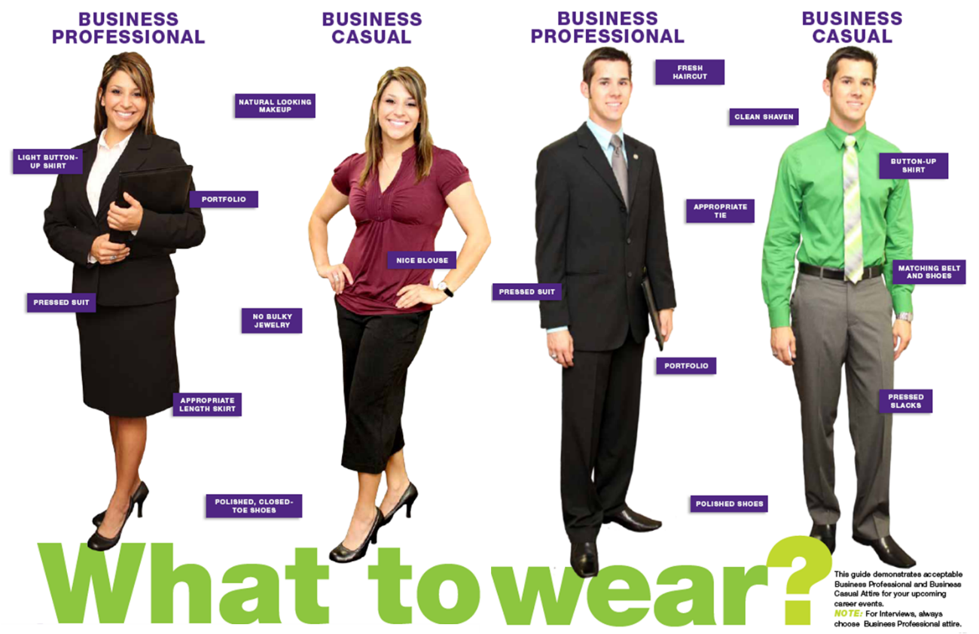
Credit: https://www.tarleton.edu/careerservices/Students/dress-to-impress.html

What Not to Wear:
Jeans, shorts, short skirts, sweatpants, sweatshirts, t-shirts, sneakers and flip-flops. In general, anything you would wear to go out dancing or to hang out with your friends should not be worn to a professional event.
Credit: https://www.tarleton.edu/careerservices/Students/dress-to-impress.html

